**EXPERIMENT NO. 4**

**AIM:** Familiarization with Packet Tracer Simulation tool/any other related tool.

**MATERIAL AND REQUIREMENTS**:

* Computers with Packet Tracer software installed (or access to an online version).
* Internet connectivity for downloading and installing Packet Tracer.

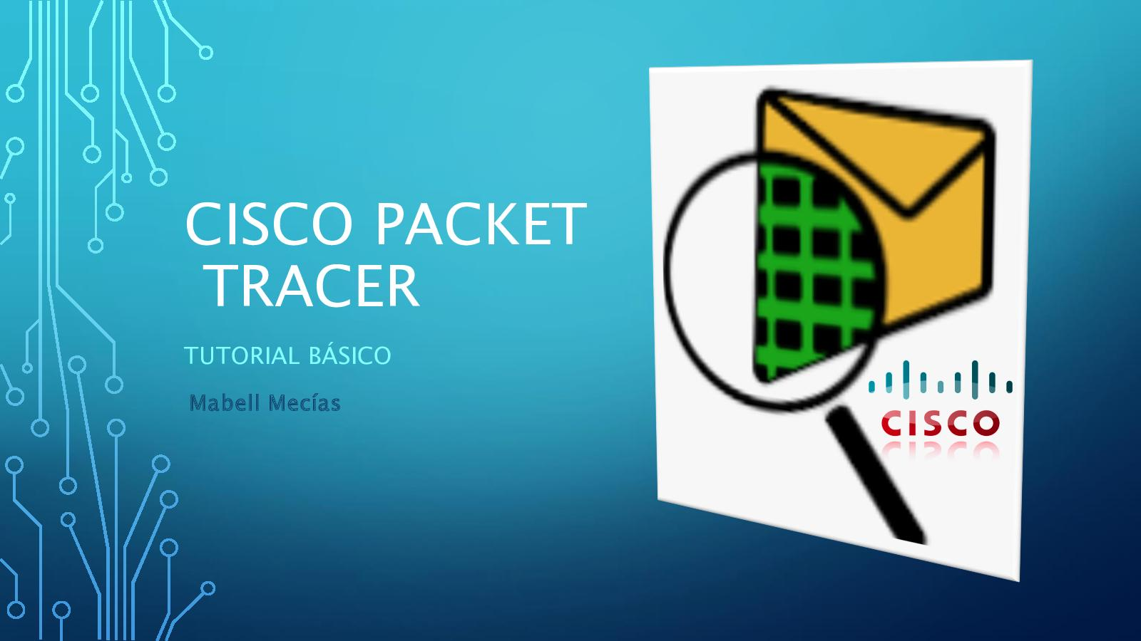

**INTRODUCTION**:

Packet Tracer is a valuable tool for networking students and professionals. It allows users to design, configure, and simulate network topologies without the need for physical hardware. This practical aims to familiarize students with the basics of using Packet Tracer.

**PROCEDURE:**

**Part 1:** Introduction to Packet Tracer

**Overview of Packet Tracer:**

* Cisco Packet Tracer is a powerful network simulation tool developed by Cisco Systems, a global leader in networking technology. It is widely used in educational settings and by networking professionals for designing, configuring, and simulating network topologies. Here is an overview of Cisco Packet Tracer:

**Downloading and Installing Packet Tracer (if not already installed):**

* Installation in Windows is pretty simple and straightforward; the setup comes in a single file named Packettracer_Setup6.0.1.exe. Open this file to begin the setup wizard, accept the license agreement, choose a location, and start the installation..

**Launching Packet Tracer:**

* Demonstrate how to launch the software and open a new project.

**Part 2:** Navigating Packet Tracer

**User Interface**:

* Present the main elements of the Packet Tracer interface, including the workspace, device palette, and toolbar.
* Explain the purpose of each section.

**Creating a Simple Network:**

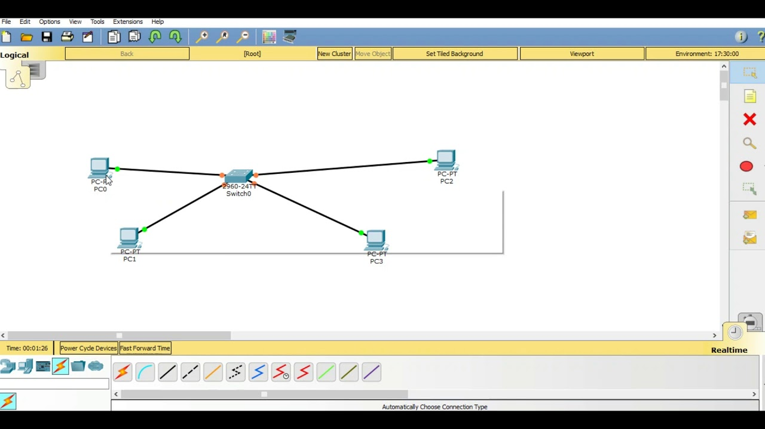

**Part 3**: Configuring Network Devices

**Device Configuration:**

* Explain how to configure network devices by double-clicking them.

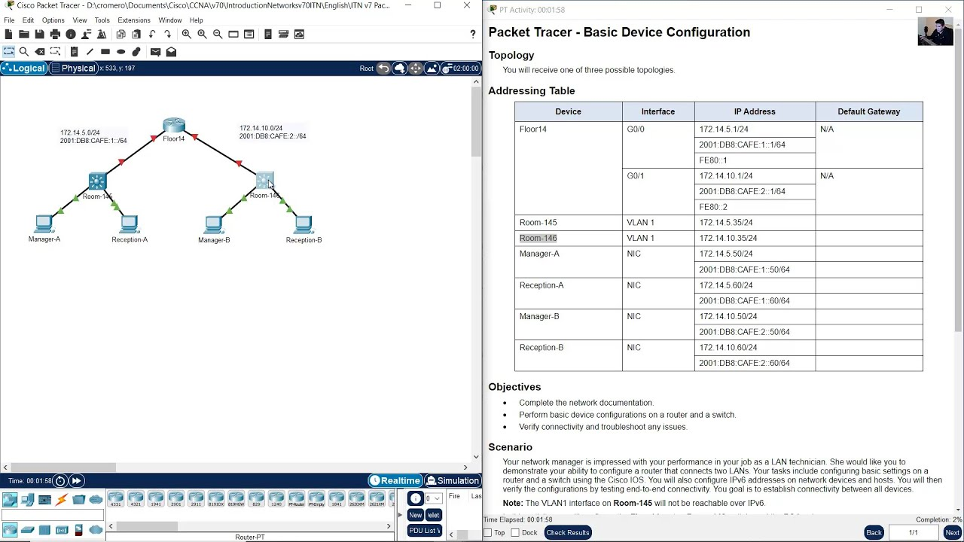

**Implementing Simple Network Scenarios:**

* Demonstrate how to configure a router to communicate with a switch, a PC, or another device.
* Create simple scenarios, such as setting up a local network and ensuring devices can communicate.

